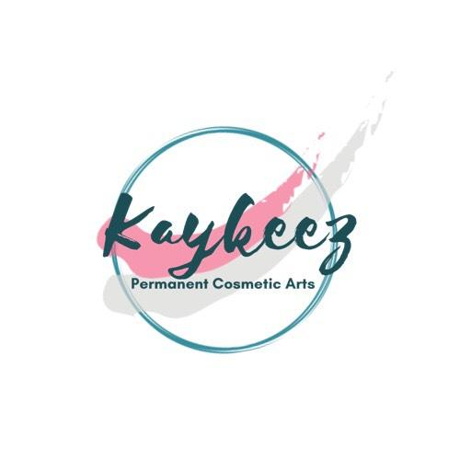
Client File Date:__________________
Name: _____________________________________Date of Birth:____/_____/______ Age_____
Ethnicity(s):______________________________________________________________________
Skin Type________________________________________________________________________
Address:_________________________________________________________________________
City:_____________________________ State:__________________Zip:_____________________
Cell:__________________________ Is texting ok? Y / N
Emergency Contact:_______________________________________________________________
- Relationship:____________________________________________________________
- Cell:___________________________________________________________________

How did you hear about Kaykeez Permanent Cosmetics!?:__________________________________________________________________

Medical History
Please circle Y (yes) or N (no) to the following questions:

- Are you over the Age of 18? Y / N
- Do you have a history of Cold Sores, Chicken Pox or Shingles? Y / N
- Have you ever had ocular herpes? Y / N
- Are you sensitive to latex? Y / N
- Have you had a chemical peel within the past 12 months? If so, when? ____ Y / N
- Do you have any difficulties healing? Y / N
- Are you using any skincare products containing retinol? Y / N
- Do you wear contact lenses? Y / N
- if yes, Do you understand that they will need to be removed during an eyeliner procedure and should not be replaced until the following day? Y / N
- Are you allergic to any metal? Y / N
- Are you allergic to any topical ointments that you are aware of? Y / N
- Are You allergic to any makeup or ingredients found in makeup such as fragrance or colorant? Y / N
- Are you allergic or sensitive to cotton? Y / N
- Do you have Any blood borne diseases such as AIDS, HIV or Hepatitis? Y / N
- Do you have a history of any Skin disease or Major Skin sensitivities? Y / N
- Are you presently taking Vitamins A and/or E in any form? Y / N
- Are you pregnant or nursing Y / N
- Are you required to take antibiotics during dental or invasive medical procedures? Y / N

Please select any of the following that pertain to you:
- Heart Conditions | - Glaucoma | - Hyper-Pigmentation (darkening of the skin)
- Allergies to makeup | - Trichotillomania | - Hypo-Pigmentation (Lightening of the skin)
- Accutane treatment | - Hepatitis/ Jaundice / HIV | - Cold Sores/ Chicken Pox/ Shingles
- Dry eyes | - Laser removal | - Ocular Herpes
- Keloid scarring | - On Thyroid Medication | - Anxiety/Panic Attacks
- Autoimmune disorders | - Kidney Disease | - Phobia of needles or invasive procedures
- laser eye surgery | - Tendency to bleed excessively | - Cancer: ________

Please explain any selected items: ___________________________________________________________________________________________________________

Please list any Medications you are currently taking:
___________________________________________________________________________________________________________

Please list any other medical conditions:
___________________________________________________________________________________________________________

Doctors Name:___________________________________________________Phone#______________________________________

***The practitioner makes no attempt to, or claim to, practice medicine. Some individuals will have complications related to Permanent Makeup Application. These complications are usually mild and last only a few days. However, extreme complications are always a possibility. If you are healthy, Have not withheld any information and there are no visible reasons restricting you from receiving a tattoo, we will proceed only after you approve the design and color before the application of your permanent makeup/tattoo.****

__________________________________________________________________________________
{First Name} {Last Name } Signature Date

Informed Consent
Please review the section below, filling in the blanks and initialing where appropriate.

The nature and method of the proposed Permanent Makeup (Tattoo) Procedure has been explained to me as having the unusual risk inherent in the procedure and the possibility of complications during and following its performance. I understand that there may be a certain amount of discomfort or pain associated with the procedure and that other adverse side effects may include minor or temporary bleeding, bruising, redness or other discolorations or swelling. Cold Sores may occur on the lips following lip procedures in individuals prone to the problem, even if you’ve taken Valtrex or similar medications prescribed by your doctor. Fading or loss of pigment may occur. Secondary infection in the procedure area may occur; however, if properly cared for the occurrences are rare.
I,_________________________, acknowledge by signing below that I have been given the full opportunity to ask any and all questions which I might have about the procedure from the practitioner, Kayleigh Bragg (and/or associates). I also acknowledge that all of my questions have been answered to my complete satisfaction. I specifically acknowledge that I have been advised of the facts and matters set below, and I agree as follows:
- I acknowledge that it is not reasonably possible to determine whether I might have an allergic reaction to anything that is used during the procedure and I agree to accept the risk that such a reaction is possible.____________(Initial)
- I have informed the practitioner of any existing problems.____________(Initial)
- I understand the importance of keeping this form up to date as certain medications and medical conditions can negatively affect the results of the procedure and in some cases be very dangerous____________(Initial)
- I acknowledge that complications are always possible as a result of a permanent makeup/Tattoo Procedure, Particularly if the post care instructions are not followed.____________(Initial)
- I acknowledge that my body is unique and the practitioner or any associates cannot predict how my skin will react to the procedure.____________(Initial)
- I acknowledge that the procedure will result in permanent change to my appearance and that the practitioner has not given me any reason to believe otherwise.____________(Initial)
- I understand that future laser treatments or other skin altering procedures (such as plastic surgery) may negatively affect my permanent makeup.____________(Initial)
- For the purpose of education or assistance I consent to the admittance of authorized observers to the procedure.____________(Initial)
- I acknowledge that the obtaining of permanent makeup procedures is my choice alone and I consent to the application of the procedure and its risks, and to any actions or conduct of the practitioner and/or any of the practitioners associates reasonable necessary to perform the procedure.____________(Initial)
- I understand that ,although my technician is trained to identify contraindications to avoid complications during or after the procedure, that she is not a medical professional and can not be expected to be educated in all conditions, medications and how they may affect PMU or vice versa. In a case in which the technician is not familiar or uncertain about a medical condition or medication I agree to provide her with a signed doctor's note clearing the technician to perform the procedure.____________(Initial)

***I am hereby stating that I have filled out the form to the best of my knowledge and have not withheld any medical information from the technician. This agreement is indefinitely binding while I am a Client at this establishment. I have read and understand the contents of each paragraph above. I acknowledge that this is a contract and that I have received no warranties or guarantees with respect to the outcome of the procedures. I further acknowledge that at the time of signing this consent to the procedure that I was of sound mind and capable of making independent decisions for myself.

________________________________________  [First name] | ________________________________________  [Last name] | __________________________________  Signature Date

Model Release

I , ____________________, hereby consent to and authorize the practitioner to take photos/videos of me at anytime before, during or after the procedure. They have an irrevocable, perpetual and unrestricted right and permission to take, use, publish and watermark pictures/videos of me. They have permission to alter the images as they so wish and have unrestricted rights to the images and their distribution. The practitioner does not need my approval to post the photos/videos under any circumstances. I understand that these will be published on the internet via Social Media for promotional purposes.
I hereby declare that I am of full age and have read, understand and agree to the above authorization model release agreement.

__________________________________________________________________________________
{First Name} { Last Name } Signature Date

